Group members names_______________________________________ period #______

________________________________________________________________ kitchen #___

FROZEN PUDDING POPS

* 1 pkg. (3.9 oz.) JELL-O Instant Pudding
* 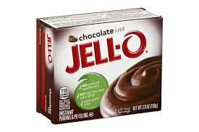2 cups cold milk

***Directions:***

____all______1. Tie up hair and wash hands.

____________2. Fill sink with soap and hot water.

____________3. Empty Jell-O into large bowl.

____________4. Measure 2 cups milk in a liquid measuring cup & add to pudding mix.

____________5. Using a wire whisk quickly beat milk & pudding mix for 2 minutes.

____________6. Get 1 cup per group member.

____________7. Equally pour pudding mixture into cups.

____________8. Cover each cup with a small piece of tin foil.

____________9. Poke a popsicle stick through the tin foil covering each cup in the center.

___________10. Place filled pudding cups in small square pan. On a small piece of paper write

your period & kitchen number. Place paper in pan with pudding cups.

___________11. Carefully give your pan to Mrs. Cislo to place in the freezer.

___________12. Wash dishes.

___________13. Dry dishes

___________14. Wash counter and work space.

___________15. Put dry dishes away.

___________16. Call teacher for kitchen inspection.